Assignment:-6

Student Registration Form with SQLite (CRUD Operations).

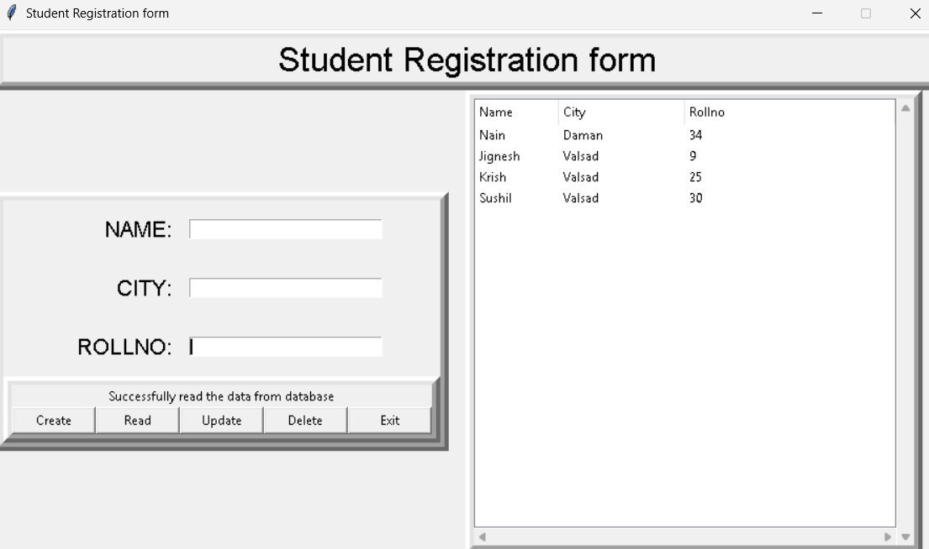

from tkinter import *
import sqlite3
import tkinter.ttk as ttk
import tkinter.messagebox as tkMessageBox

# ----------------- DATABASE -----------------
def Database():
global conn, cursor
conn = sqlite3.connect('computer.db')
cursor = conn.cursor()
cursor.execute("""
CREATE TABLE IF NOT EXISTS member (
mem_id INTEGER PRIMARY KEY AUTOINCREMENT NOT NULL,
name TEXT,
city TEXT,
rollno INTEGER
)
""")

def Create():
if NAME.get() == "" or CITY.get() == "" or ROLLNO.get() == "":
txt_result.config(text="Please complete the required field!", fg="red")
else:
Database()
cursor.execute("INSERT INTO member (name,city,rollno) VALUES (?,?,?)",
(str(NAME.get()), str(CITY.get()), str(ROLLNO.get())))
conn.commit()
NAME.set("")
CITY.set("")
ROLLNO.set("")
cursor.close()
conn.close()
txt_result.config(text="Created a data!", fg="green")

def Read():
tree.delete(*tree.get_children())
Database()
cursor.execute("SELECT * FROM member ORDER BY city ASC")
fetch = cursor.fetchall()
for data in fetch:
tree.insert("", 'end', values=(data[1], data[2], data[3]))
cursor.close()
txt_result.config(text="Successfully read the data from database", fg="black")

def Update():
if NAME.get() == "" or CITY.get() == "" or ROLLNO.get() == "":
txt_result.config(text="Please complete the required field!", fg="red")
else:
Database()
cursor.execute("UPDATE member SET name=?, city=? WHERE rollno=?",
(str(NAME.get()), str(CITY.get()), str(ROLLNO.get())))
conn.commit()
NAME.set("")
CITY.set("")
ROLLNO.set("")
cursor.close()
conn.close()
txt_result.config(text="Update a data!", fg="green")

def Delete():
if NAME.get() == "" or ROLLNO.get() == "":
txt_result.config(text="Please complete the required field!", fg="red")
else:
Database()
cursor.execute("DELETE FROM member WHERE name=? AND rollno=?",
(str(NAME.get()), str(ROLLNO.get())))
conn.commit()
NAME.set("")
ROLLNO.set("")
cursor.close()
conn.close()
txt_result.config(text="Delete a data!", fg="green")

def Exit():
result = tkMessageBox.askquestion('Student Registration form',
'Are you sure you want to exit?', icon="warning")
if result == 'yes':
root.destroy()
exit()

# ----------------- GUI -----------------
root = Tk()
root.title("Student Registration form")

screen_width = root.winfo_screenwidth()
screen_height = root.winfo_screenheight()
width = 900
height = 500
x = (screen_width/2) - (width/2)
y = (screen_height/2) - (height/2)
root.geometry('%dx%d+%d+%d' % (width, height, x, y))
root.resizable(0, 0)

NAME = StringVar()
CITY = StringVar()
ROLLNO = StringVar()

Top = Frame(root, width=900, height=50, bd=8, relief="raise")
Top.pack(side=TOP)

Left = Frame(root, width=300, height=500, bd=8, relief="raise")
Left.pack(side=LEFT)

Right = Frame(root, width=600, height=500, bd=8, relief="raise")
Right.pack(side=TOP)

Forms = Frame(Left, width=300, height=450)
Forms.pack(side=TOP)

Buttons = Frame(Left, width=300, height=100, bd=8, relief="raise")
Buttons.pack(side=BOTTOM)

txt_title = Label(Top, width=900, font=('arial', 24), text="Student Registration form")
txt_title.pack()

txt_name = Label(Forms, text="NAME:", font=('arial', 16), bd=15)
txt_name.grid(row=0, stick="e")

txt_city = Label(Forms, text="CITY:", font=('arial', 16), bd=15)
txt_city.grid(row=1, stick="e")

txt_rollno = Label(Forms, text="ROLLNO:", font=('arial', 16), bd=15)
txt_rollno.grid(row=2, stick="e")

txt_result = Label(Buttons)
txt_result.pack(side=TOP)

name = Entry(Forms, textvariable=NAME, width=30)
name.grid(row=0, column=1)

city = Entry(Forms, textvariable=CITY, width=30)
city.grid(row=1, column=1)

rollno = Entry(Forms, textvariable=ROLLNO, width=30)
rollno.grid(row=2, column=1)

btn_create = Button(Buttons, width=10, text="Create", command=Create)
btn_create.pack(side=LEFT)

btn_read = Button(Buttons, width=10, text="Read", command=Read)
btn_read.pack(side=LEFT)

btn_update = Button(Buttons, width=10, text="Update", command=Update)
btn_update.pack(side=LEFT)

btn_delete = Button(Buttons, width=10, text="Delete", command=Delete)
btn_delete.pack(side=LEFT)

btn_exit = Button(Buttons, width=10, text="Exit", command=Exit)
btn_exit.pack(side=LEFT)

scrollbary = Scrollbar(Right, orient=VERTICAL)
scrollbarx = Scrollbar(Right, orient=HORIZONTAL)

tree = ttk.Treeview(Right, column=("Name", "City", "Rollno"),
selectmode="extended", height=500,
yscrollcommand=scrollbary.set,
xscrollcommand=scrollbarx.set)

scrollbary.config(command=tree.yview)
scrollbary.pack(side=RIGHT, fill=Y)

scrollbarx.config(command=tree.xview)
scrollbarx.pack(side=BOTTOM, fill=X)

tree.heading('Name', text="Name", anchor=W)
tree.heading('City', text="City", anchor=W)
tree.heading('Rollno', text="Rollno", anchor=W)

tree.column('#0', stretch=NO, minwidth=0, width=0)
tree.column('#1', stretch=NO, minwidth=0, width=80)
tree.column('#2', stretch=NO, minwidth=0, width=120)
tree.pack()

root.mainloop()

Question 2 : Student Registration with SQLite (College Database).

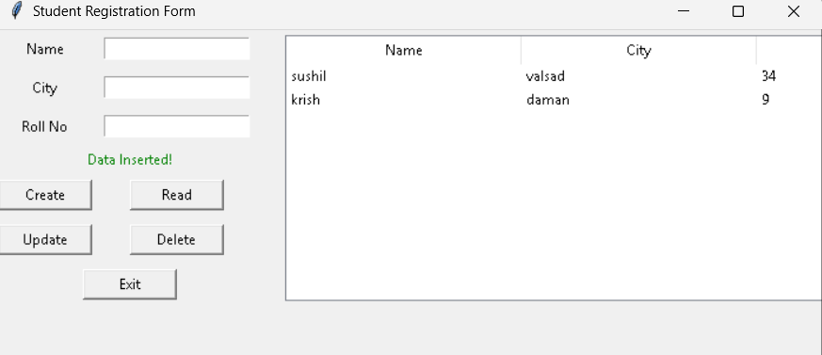

from tkinter import *
import sqlite3
from tkinter import ttk, messagebox

# ---------------- Database ----------------
def Database():
conn = sqlite3.connect("college.db")
cursor = conn.cursor()
cursor.execute("""
CREATE TABLE IF NOT EXISTS student (
stud_id INTEGER PRIMARY KEY AUTOINCREMENT,
name TEXT,
city TEXT,
rollno INTEGER
)
""")
conn.commit()
conn.close()

# ---------------- CRUD Functions ----------------
def Create():
if NAME.get()=="" or CITY.get()=="" or ROLLNO.get()=="":
lbl_msg.config(text="Please fill all fields!", fg="red")
else:
conn = sqlite3.connect("college.db")
cursor = conn.cursor()
cursor.execute("INSERT INTO student (name, city, rollno) VALUES (?, ?, ?)",
(NAME.get(), CITY.get(), ROLLNO.get()))
conn.commit()
conn.close()
NAME.set(""); CITY.set(""); ROLLNO.set("")
lbl_msg.config(text="Data Inserted!", fg="green")
Read()

def Read():
tree.delete(*tree.get_children())
conn = sqlite3.connect("college.db")
cursor = conn.cursor()
cursor.execute("SELECT name, city, rollno FROM student")
for row in cursor.fetchall():
tree.insert("", END, values=row)
conn.close()

def Update():
if NAME.get()=="" or CITY.get()=="" or ROLLNO.get()=="":
lbl_msg.config(text="Please fill all fields!", fg="red")
else:
conn = sqlite3.connect("college.db")
cursor = conn.cursor()
cursor.execute("UPDATE student SET name=?, city=? WHERE rollno=?",
(NAME.get(), CITY.get(), ROLLNO.get()))
conn.commit()
conn.close()
NAME.set(""); CITY.set(""); ROLLNO.set("")
lbl_msg.config(text="Data Updated!", fg="green")
Read()

def Delete():
if ROLLNO.get()=="":
lbl_msg.config(text="Enter RollNo to delete!", fg="red")
else:
conn = sqlite3.connect("college.db")
cursor = conn.cursor()
cursor.execute("DELETE FROM student WHERE rollno=?", (ROLLNO.get(),))
conn.commit()
conn.close()
NAME.set(""); CITY.set(""); ROLLNO.set("")
lbl_msg.config(text="Data Deleted!", fg="green")
Read()

def Exit():
if messagebox.askyesno("Exit", "Are you sure you want to exit?"):
root.destroy()

# ---------------- GUI ----------------
root = Tk()
root.title("Student Registration Form")
root.geometry("700x400")

NAME = StringVar()
CITY = StringVar()
ROLLNO = StringVar()

# Labels & Entries
Label(root, text="Name").grid(row=0, column=0, padx=10, pady=5)
Entry(root, textvariable=NAME).grid(row=0, column=1, padx=10, pady=5)

Label(root, text="City").grid(row=1, column=0, padx=10, pady=5)
Entry(root, textvariable=CITY).grid(row=1, column=1, padx=10, pady=5)

Label(root, text="Roll No").grid(row=2, column=0, padx=10, pady=5)
Entry(root, textvariable=ROLLNO).grid(row=2, column=1, padx=10, pady=5)

lbl_msg = Label(root, text="", fg="red")
lbl_msg.grid(row=3, column=0, columnspan=2)

# Buttons
Button(root, text="Create", command=Create, width=10).grid(row=4, column=0, pady=5)
Button(root, text="Read", command=Read, width=10).grid(row=4, column=1, pady=5)
Button(root, text="Update", command=Update, width=10).grid(row=5, column=0, pady=5)
Button(root, text="Delete", command=Delete, width=10).grid(row=5, column=1, pady=5)
Button(root, text="Exit", command=Exit, width=10).grid(row=6, column=0, columnspan=2, pady=5)

# Treeview (Table)
tree = ttk.Treeview(root, columns=("Name", "City", "Rollno"), show="headings")
tree.heading("Name", text="Name")
tree.heading("City", text="City")
tree.heading("Rollno", text="Roll No")
tree.grid(row=0, column=2, rowspan=7, padx=20, pady=5)

Database()
Read()
root.mainloop()

Question:-Patient Registration System with SQLite.

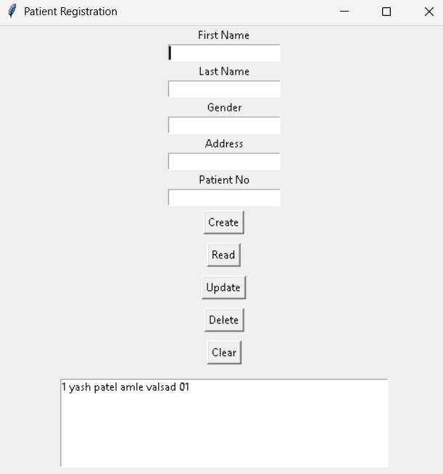

from tkinter import *
import sqlite3
from tkinter import messagebox

# -------- Database Setup --------
def Database():
conn = sqlite3.connect("patient.db")
cursor = conn.cursor()
cursor.execute("""
CREATE TABLE IF NOT EXISTS patient (
patient_id INTEGER PRIMARY KEY AUTOINCREMENT,
firstname TEXT,
lastname TEXT,
gender TEXT,
address TEXT,
patientno TEXT
)
""")
conn.commit()
conn.close()

# -------- CRUD Functions --------
def Create():
if firstname.get()=="" or lastname.get()=="" or gender.get()=="" or address.get()=="" or patientno.get()=="":
messagebox.showerror("Error", "All fields required!")
else:
conn = sqlite3.connect("patient.db")
cursor = conn.cursor()
cursor.execute("INSERT INTO patient(firstname,lastname,gender,address,patientno) VALUES(?,?,?,?,?)",
(firstname.get(), lastname.get(), gender.get(), address.get(), patientno.get()))
conn.commit()
conn.close()
messagebox.showinfo("Success", "Record Added")
Clear()

def Read():
conn = sqlite3.connect("patient.db")
cursor = conn.cursor()
cursor.execute("SELECT * FROM patient")
rows = cursor.fetchall()
conn.close()
listbox.delete(0, END)
for row in rows:
listbox.insert(END, row)

def Update():
if patientno.get()=="":
messagebox.showerror("Error", "Enter Patient No to update")
else:
conn = sqlite3.connect("patient.db")
cursor = conn.cursor()
cursor.execute("UPDATE patient SET firstname=?, lastname=?, gender=?, address=? WHERE patientno=?",
(firstname.get(), lastname.get(), gender.get(), address.get(), patientno.get()))
conn.commit()
conn.close()
messagebox.showinfo("Success", "Record Updated")
Clear()

def Delete():
if patientno.get()=="":
messagebox.showerror("Error", "Enter Patient No to delete")
else:
conn = sqlite3.connect("patient.db")
cursor = conn.cursor()
cursor.execute("DELETE FROM patient WHERE patientno=?", (patientno.get(),))
conn.commit()
conn.close()
messagebox.showinfo("Success", "Record Deleted")
Clear()

def Clear():
firstname.set("")
lastname.set("")
gender.set("")
address.set("")
patientno.set("")

# -------- Tkinter GUI --------
root = Tk()
root.title("Patient Registration")
root.geometry("500x500")

firstname = StringVar()
lastname = StringVar()
gender = StringVar()
address = StringVar()
patientno = StringVar()

Label(root, text="First Name").pack()
Entry(root, textvariable=firstname).pack()

Label(root, text="Last Name").pack()
Entry(root, textvariable=lastname).pack()

Label(root, text="Gender").pack()
Entry(root, textvariable=gender).pack()

Label(root, text="Address").pack()
Entry(root, textvariable=address).pack()

Label(root, text="Patient No").pack()
Entry(root, textvariable=patientno).pack()

Button(root, text="Create", command=Create).pack(pady=5)
Button(root, text="Read", command=Read).pack(pady=5)
Button(root, text="Update", command=Update).pack(pady=5)
Button(root, text="Delete", command=Delete).pack(pady=5)
Button(root, text="Clear", command=Clear).pack(pady=5)

listbox = Listbox(root, width=60, height=10)
listbox.pack(pady=10)

Database()
root.mainloop()

Question:- Member Registration System with Login Details.

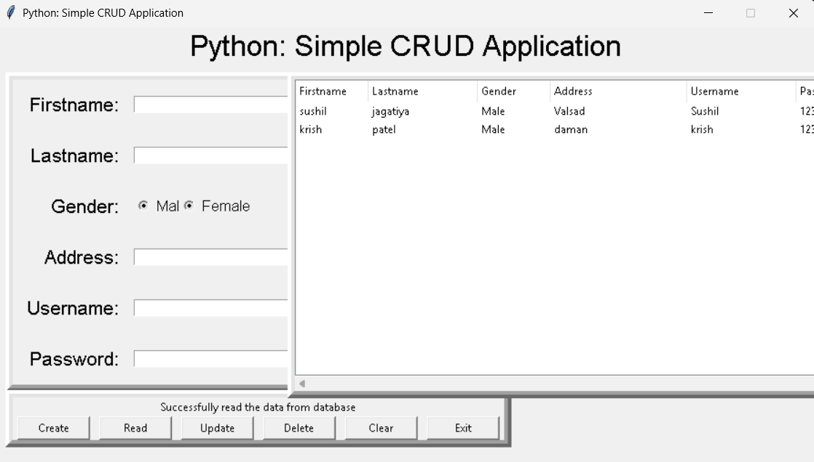

from tkinter import *
import sqlite3
import tkinter.ttk as ttk
import tkinter.messagebox as tkMessageBox

# ---------- Database ----------
def Database():
global conn, cursor
conn = sqlite3.connect("pythontut.db")
cursor = conn.cursor()
cursor.execute("""
CREATE TABLE IF NOT EXISTS member (
mem_id INTEGER PRIMARY KEY AUTOINCREMENT NOT NULL,
firstname TEXT,
lastname TEXT,
gender TEXT,
address TEXT,
username TEXT,
password TEXT
)
""")

# ---------- CRUD Functions ----------
def Create():
if (FIRSTNAME.get()=="" or LASTNAME.get()=="" or GENDER.get()=="" or
ADDRESS.get()=="" or USERNAME.get()=="" or PASSWORD.get()==""):
txt_result.config(text="Please complete the required field!", fg="red")
else:
Database()
cursor.execute("INSERT INTO member(firstname,lastname,gender,address,username,password) VALUES(?,?,?,?,?,?)",
(FIRSTNAME.get(), LASTNAME.get(), GENDER.get(), ADDRESS.get(), USERNAME.get(), PASSWORD.get()))
conn.commit()
Clear()
cursor.close()
conn.close()
txt_result.config(text="Created a data!", fg="green")

def Read():
tree.delete(*tree.get_children())
Database()
cursor.execute("SELECT * FROM member ORDER BY lastname ASC")
fetch = cursor.fetchall()
for data in fetch:
tree.insert('', 'end', values=(data[1], data[2], data[3], data[4], data[5], data[6]))
cursor.close()
conn.close()
txt_result.config(text="Successfully read the data from database", fg="black")

def Update():
if PASSWORD.get()=="":
txt_result.config(text="Please enter Password to update!", fg="red")
else:
Database()
cursor.execute("UPDATE member SET firstname=?, lastname=?, gender=?, address=?, username=? WHERE password=?",
(FIRSTNAME.get(), LASTNAME.get(), GENDER.get(), ADDRESS.get(), USERNAME.get(), PASSWORD.get()))
conn.commit()
Clear()
cursor.close()
conn.close()
txt_result.config(text="Updated a data!", fg="green")

def Delete():
if FIRSTNAME.get()=="" or ADDRESS.get()=="":
txt_result.config(text="Please complete the required field!", fg="red")
else:
Database()
cursor.execute("DELETE FROM member WHERE firstname=? AND address=?", (FIRSTNAME.get(), ADDRESS.get()))
conn.commit()
Clear()
cursor.close()
conn.close()
txt_result.config(text="Deleted a data!", fg="green")

def Clear():
FIRSTNAME.set("")
LASTNAME.set("")
GENDER.set("")
ADDRESS.set("")
USERNAME.set("")
PASSWORD.set("")

def Exit():
result = tkMessageBox.askquestion("Python: Simple CRUD Application",
"Are you sure you want to exit?", icon="warning")
if result == "yes":
root.destroy()
exit()

# ---------- GUI ----------
root = Tk()
root.title("Python: Simple CRUD Application")
root.geometry("900x500")
root.resizable(0, 0)

# Variables
FIRSTNAME = StringVar()
LASTNAME = StringVar()
GENDER = StringVar()
ADDRESS = StringVar()
USERNAME = StringVar()
PASSWORD = StringVar()

# Top Frame
txt_title = Label(root, width=900, font=("arial", 24), text="Python: Simple CRUD Application")
txt_title.pack(side=TOP)

# Form
form_frame = Frame(root, bd=8, relief="raise")
form_frame.place(x=10, y=50)

Label(form_frame, text="Firstname:", font=("arial", 16), bd=15).grid(row=0, column=0, sticky="e")
Entry(form_frame, textvariable=FIRSTNAME, width=30).grid(row=0, column=1)

Label(form_frame, text="Lastname:", font=("arial", 16), bd=15).grid(row=1, column=0, sticky="e")
Entry(form_frame, textvariable=LASTNAME, width=30).grid(row=1, column=1)

Label(form_frame, text="Gender:", font=("arial", 16), bd=15).grid(row=2, column=0, sticky="e")
Radiobutton(form_frame, text="Male", variable=GENDER, value="Male", font=("arial", 12)).grid(row=2, column=1, sticky="w")
Radiobutton(form_frame, text="Female", variable=GENDER, value="Female", font=("arial", 12)).grid(row=2, column=1)

Label(form_frame, text="Address:", font=("arial", 16), bd=15).grid(row=3, column=0, sticky="e")
Entry(form_frame, textvariable=ADDRESS, width=30).grid(row=3, column=1)

Label(form_frame, text="Username:", font=("arial", 16), bd=15).grid(row=4, column=0, sticky="e")
Entry(form_frame, textvariable=USERNAME, width=30).grid(row=4, column=1)

Label(form_frame, text="Password:", font=("arial", 16), bd=15).grid(row=5, column=0, sticky="e")
Entry(form_frame, textvariable=PASSWORD, show="*", width=30).grid(row=5, column=1)

# Buttons
btn_frame = Frame(root, bd=8, relief="raise")
btn_frame.place(x=10, y=400)

txt_result = Label(btn_frame)
txt_result.pack(side=TOP)

Button(btn_frame, width=10, text="Create", command=Create).pack(side=LEFT, padx=5)
Button(btn_frame, width=10, text="Read", command=Read).pack(side=LEFT, padx=5)
Button(btn_frame, width=10, text="Update", command=Update).pack(side=LEFT, padx=5)
Button(btn_frame, width=10, text="Delete", command=Delete).pack(side=LEFT, padx=5)
Button(btn_frame, width=10, text="Clear", command=Clear).pack(side=LEFT, padx=5)
Button(btn_frame, width=10, text="Exit", command=Exit).pack(side=LEFT, padx=5)

# Treeview
tree_frame = Frame(root, bd=8, relief="raise")
tree_frame.place(x=320, y=50)

scrollbary = Scrollbar(tree_frame, orient=VERTICAL)
scrollbarx = Scrollbar(tree_frame, orient=HORIZONTAL)
tree = ttk.Treeview(tree_frame,
columns=("Firstname", "Lastname", "Gender", "Address", "Username", "Password"),
selectmode="extended", height=15,
yscrollcommand=scrollbary.set, xscrollcommand=scrollbarx.set)
scrollbary.config(command=tree.yview)
scrollbarx.config(command=tree.xview)
scrollbary.pack(side=RIGHT, fill=Y)
scrollbarx.pack(side=BOTTOM, fill=X)

tree.heading("Firstname", text="Firstname", anchor=W)
tree.heading("Lastname", text="Lastname", anchor=W)
tree.heading("Gender", text="Gender", anchor=W)
tree.heading("Address", text="Address", anchor=W)
tree.heading("Username", text="Username", anchor=W)
tree.heading("Password", text="Password", anchor=W)

tree.column("#0", stretch=NO, minwidth=0, width=0)
tree.column("#1", stretch=NO, minwidth=0, width=80)
tree.column("#2", stretch=NO, minwidth=0, width=120)
tree.column("#3", stretch=NO, minwidth=0, width=80)
tree.column("#4", stretch=NO, minwidth=0, width=150)
tree.column("#5", stretch=NO, minwidth=0, width=120)
tree.column("#6", stretch=NO, minwidth=0, width=120)
tree.pack()

root.mainloop()

